**Project Planning Phase**

**Project Planning (Product Backlog, Sprint Planning, Stories, Story points)**

|  |  |
| --- | --- |
| Date | 26 October 2022 |
| Team ID | PNT2022TMID27784 |
| Project Name | AI BASED DISCOURSE FOR BANKING INDUSTRY |
| Maximum Marks | 8 Marks |

**Product Backlog, Sprint Schedule, and Estimation (4 Marks)**

Use the below template to create product backlog and sprint schedule

|  |  |  |  |  |  |  |
| --- | --- | --- | --- | --- | --- | --- |
| **Sprint** | **Functional**  **Requirement (Epic)** | **User Story**  **Number** | **User Story / Task** | **Story Points** | **Priority** | **Team Members** |
| Sprint-1 | Savings Account Related Actions | USN-1 | As a user, in the Savings Account option, I can select Types of Savings Account to get  details regarding documents required for creating that savings account. | 3 | High | Shiny.R |
| Sprint-1 |  | USN-2 | As a user, I can check the Interest Rates of Savings Account | 3 | High | Nithyavarshini.J, |
| Sprint-2 |  | USN-3 | As a user, I can check the Minimum Balance of Savings Account | 4 | Medium | Sri Nandhini.R |
| Sprint-1 | Current Account Related Actions | USN-4 | As a user, I can choose the Type of Company to know the information on documents to be submitted for creating current account | 3 | High | Mathivathani.B.G |
| Sprint-2 |  | USN-5 | As a user, I want to get details on procedure to close my Current Account | 6 | High | Mathivathani.B.G |
| Sprint-1 | Loan Account Related Actions | USN-6 | As a user, I can choose the Type of Loans to know the information on choosing an essential loan scheme | 3 | High | Sri Nandhini.R |
| Sprint-2 |  | USN-7 | As a user, I can check the Loan Amounts that can be offered for corresponding Loan  Accounts chosen | 6 | High | Nithyavarshini.J |
| Sprint-2 |  | USN-8 | As a user, I can check the Status of Loan for my Loan Accounts | 2 | Low | Sri nandhini.R |
| Sprint-1 | General Queries Related Actions | USN-9 | As a user, I want to get the procedure details for Currency Conversion facility of my bank account | 2 | Low | Mathivanthani.B.G |
| Sprint 3 |  | USN-10 | As a user, I want to check my CIBIL score for my loan application and to ensure whether my loan application is approved by the bank. | 4 | Medium | Nithyavarshini.J |
| Sprint-3 |  | USN-11 | As a user, I want to get the procedure details for maintaining Storage Locker facility of my bank account | 7 | High | Shiny.R, |
| Sprint-2 | Net Banking Related Actions | USN-12 | As a user, I want to get the procedure details for changing the Net Banking password of my bank account | 3 | Medium | Sri nandhini.R |
| Sprint-3 |  | USN-13 | As a user, I can select types of fund transfers to get details regarding different services available in net banking | 7 | High | Mathivanthani.B.G |
| Sprint-3 |  | USN-14 | As a user, I want to get the procedure details for adding beneficiaries to my net banking account. | 2 | Low | Shiny.R |
| Sprint-1 |  | USN-15 | As an admin, I can change responses  to queries and modify them as and when needed. | 3 | Medium | Nithyavarshini.J |
| Sprint-1 |  | USN-16 | As an admin, I can added more options to queries and add new options as new features get added. | 3 | Medium | Mathivanthani.B.G |
| Sprint-4 | Actions | USN-17 | Different Languages | 20 | High | Shiny.R  Sri nandhini.R  Nithyavarshini.J  Mathivanthani.B.G |

**Project Tracker, Velocity & Burndown Chart: (4 Marks)**

|  |  |  |  |  |  |  |  |  |  |  |  |
| --- | --- | --- | --- | --- | --- | --- | --- | --- | --- | --- | --- |
|  | **Sprint** | **Total Story Points** | | **Duration** | | **Average Velocity** | |  | | | |
| Sprint-1 | 20 | | 6 Days | | 20/6 = 3.33 | |
| Sprint-2 | 20 | | 6 Days | | 20/6 = 3.33 | |
| Sprint-3 | 20 | | 6 Days | | 20/6 = 3.33 | |
| Sprint-4 | 20 | | 6 Days | | 20/6 = 3.33 | |
| **Overall** | **80** | | **24 Days** | | **80/24 = 3.33** | |
| **Sprint** | | | **Total Story**  **Points** | | **Duration** | | **Sprint Start Date** | | **Sprint End Date (Planned)** | **Story Points**  **Completed (as on**  **Planned End Date)** | **Sprint**  **Release**  **Date**  **(Actual)** |
| Sprint-1 | | | 20 | | 6 Days | | 24 Oct 2022 | | 29 Oct 2022 | 18 | 02 Nov 2022 |
| Sprint-2 | | | 20 | | 6 Days | | 31 Oct 2022 | | 05 Nov 2022 | 22 | 05 Nov 2022 |
| Sprint-3 | | | 20 | | 6 Days | | 07 Nov 2022 | | 12 Nov 2022 | 20 | 12 Nov 2022 |
| Sprint-4 | | | 20 | | 6 Days | | 14 Nov 2022 | | 19 Nov 2022 | 20 | 19 Nov 2022 |

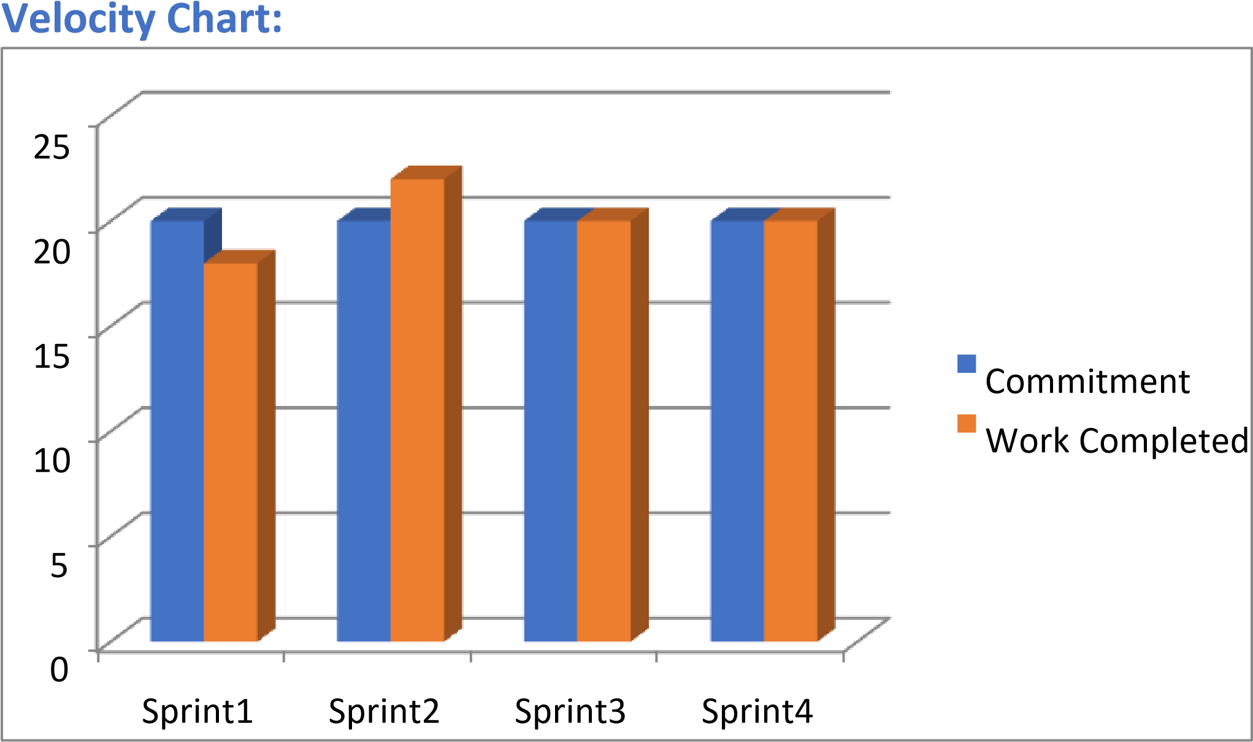

**Burndown Chart:**



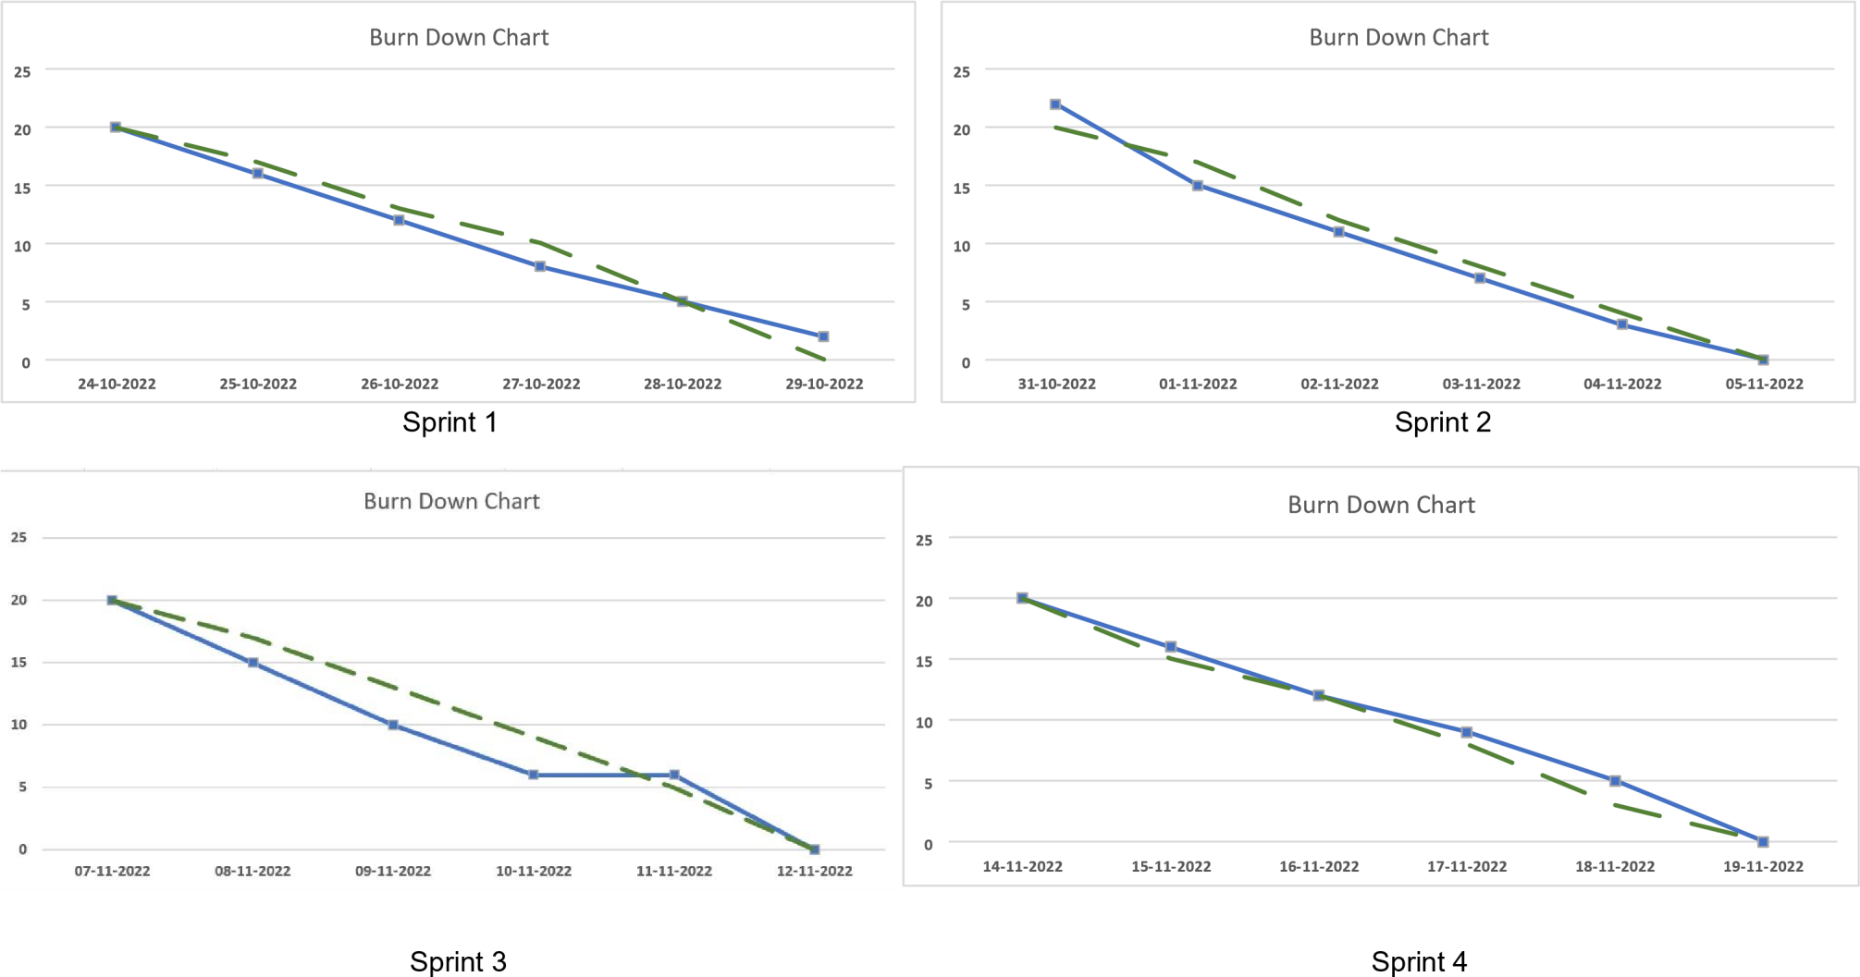

**Summary of Stand- Up Calls**

|  |  |  |  |  |  |  |  |
| --- | --- | --- | --- | --- | --- | --- | --- |
| **Question** | **Person** |  | **SPRINT-1** | | |  |  |
| **24-10-2022** | **25-10-2022** | **26-10-2022** | **27-10-2022** | **28-10-2022** | **29-10-2022** |
| What did you do yesterday? | **Shiny.R** | - | Creation of IBM  Watson Assistant Service | - | - | - | - |
| **Nithyavarshini.J** | - | Creation of IBM Watson Assistant Service | Created Queries for Types of Savings Account | Created Queries for Minimum Balance of Savings Account | - | - |
| **Mathivathani.B.G** | - | Creation of IBM Watson Assistant Service | - | - | Queries for Type of Company (Half Done) | Queries for Type of Company and Closure of  Current Account |
| **Sri Nandhini.R** | - | Creation of IBM Watson Assistant Service | - | - | - | - |
| What will you work on today? | **Nithyavarshini** | Creation of IBM Watson Assistant Service | - | - | - | - | - |
| **Sri Nandhini** | Creation of IBM Watson Assistant Service | Created Queries for Types of Savings Account | Created Queries for Minimum Balance of Savings Account | - | - | Queries to check Interest Rates of Savings Account |
| **Shiny.R** | Creation of IBM Watson Assistant Service | - | - | Queries for Type of Company | Queries for Type of Company and Closure of Current Account | - |
| **Mathivathani** | Creation of IBM Watson Assistant Service | - | - | - | - | - |

|  |  |  |  |
| --- | --- | --- | --- |
|  |  | **SPRINT-2** |  |
| **Question** | **Person** |  |  |

|  |  |  |  |  |  |  |  |
| --- | --- | --- | --- | --- | --- | --- | --- |
|  |  | **31-10-2022** | **1-11-2022** | **2-11-2022** | **3-11-2022** | **4-11-2022** | **5-11-2022** |
| What did you do yesterday? | **Sri Nandhini** | - | - | - | - | CIBIL Score | Storage Locker |
| **Nithyavarshini** | - | Complete Minimum Balance of Savings Account | - | - | - | - |
| **Mathivathani** | - | - | - | Currency Conversion | - | - |
| **Shiny** | - | - | Type of Loan | Status of Loan | CIBIL Score | Storage Locker |
| What will you work on today? | **Shiny** | - | - | - | CIBIL Score | Storage Locker | - |
| **Sri nandhini** | Complete Minimum Balance of Savings Account | - | - | - | - | - |
| Nithyavarshini | - | - | Currency Conversion | - | - | - |
| Mathivathani | - | Type of Loan | Status of Loan | CIBIL Score | Storage Locker | Loan Amount |

|  |  |  |  |
| --- | --- | --- | --- |
|  |  | **SPRINT-3** |  |
| **Question** | **Person** |  |  |

|  |  |  |  |  |  |  |  |
| --- | --- | --- | --- | --- | --- | --- | --- |
|  |  | **07-11-2022** | **08-11-2022** | **09-11-2022** | **10-11-2022** | **11-11-2022** | **12-11-2022** |
| What did you do yesterday? | **Nithyavarshini.J** | - | - | - | - | - | - |
| **Sri Nandhini** | - | - | - | - | - | - |
| **Shiny.R** | - | Tutorial Videos on Flask | Install Flask and the Relevant Dependencies | Design a Simple Webpage to host through Flask | - | Run and check the application |
| **Mathivathani** | - | Tutorial Videos on Flask | Install Flask and the Relevant Dependencies | Design a Simple Webpage to host through Flask | - | Run and check the application |
| What will you work on today? | **Shiny** | - | - | - | - | - | - |
| **Mathivathani** | - | - | - | - | - | - |
| **Nithyavarshini** | Tutorial Videos on Flask | Install Flask and the Relevant Dependencies | Design a Simple Webpage to host through Flask | - | Run and check the application | Take the relevant screenshots |
| **Sri Nandhini** | Tutorial Videos on Flask | Install Flask and the Relevant Dependencies | Design a Simple Webpage to host through Flask | - | Run and check the application | Take the relevant screenshots |

|  |  |  |  |  |  |  |  |
| --- | --- | --- | --- | --- | --- | --- | --- |
| **Question** | **Person** |  |  | **SPRINT-4** |  |  |  |
| **14-11-2022** | **15-11-2022** | **16-11-2022** | **17-11-2022** | **18-11-2022** | **19-11-2022** |
| What did you do yesterday? | **Nithyavarshini** | - | Integrating the Chatbot | Integrating the Chatbot | Developing and Designing a Webpage | Developing and Designing a Webpage | Testing and Previewing the Chatbot |
| **Shiny** | - | Integrating the Chatbot | Integrating the Chatbot | Developing and Designing a Webpage | Developing and Designing a Webpage | Testing and Previewing the Chatbot |
|  | **Mathivathani** | - | - | - | - | - | - |
|  | **Sri Nandhini** | - | - | - | - | - | - |
| What will you do today? | **Mathivathani** | - | Integrating the Chatbot | Integrating the Chatbot | Developing and Designing a Webpage | Developing and Designing a Webpage | Testing and Previewing the Chatbot |
| **Sri Nandhini** | - | Integrating the Chatbot | Integrating the Chatbot | Developing and Designing a Webpage | Developing and Designing a Webpage | Testing and Previewing the Chatbot |
| **Shiny** | - | - | - | - | - | - |
| **Nithyavarshini** | - | - | - | - | - | - |